https://leetcode.com/problems/partition-labels/solution/

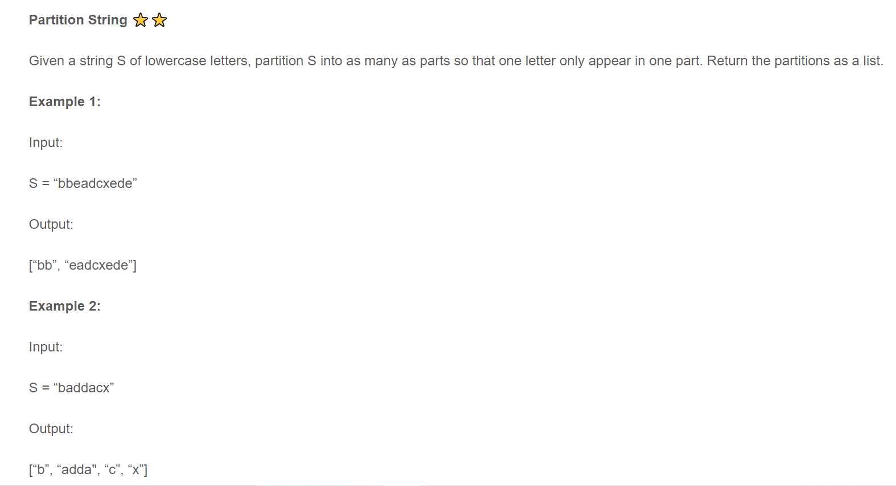

List<Integer> out = new ArrayList<>();

HashMap<Character, Integer> map = new HashMap<>();

for (int i=0; i<S.length(); i++) {

map.put(S.charAt(i), i);

}

Integer end=0, begin=0;

System.out.print(map);

for (int i=0; i<S.length(); i++) {

Integer index = map.get(S.charAt(i));

if (index.intValue() > end.intValue()) {

end = index;

}

if(i == end.intValue()) {

out.add(end.intValue() - begin.intValue() + 1);

begin = i + 1;

}

}

return out;